WAIVER

DEADLINE TO TURN PAPERWORK IN
Monday, September 9, 2024, at 5:30 PM
Please mail or email or deliver the completed Participant Sign-up Sheet(s), Hold Harmless Forms, and Map to:
Citrus County Aquatic Services
1300 S Lecanto Highway
Lecanto, FL 34461
tracey.ivkovic@citrusbocc.com
Need more information, call: (352) 527-7620
Thank you for making a difference in the health and quality of Citrus County’s waters!

I, __________________________________, hereinafter called the Group Leader recognize the need and the desirability of litter-free waterways. Individuals listed on the Participant Signup Sheet will participate in the cleanup effort on September 21, 2024.
By signing below, the Group Leader acknowledges the hazardous nature of the work and agrees to the following:
- Any participants 17 years of age or younger, shall have adult supervision.
- All participants under age 6 MUST have one-on-one adult supervision to participate.
- The Group Leader must attend the mandatory safety meeting on Monday, September 16, 2024, at 6pm in room 166 of the Lecanto Government Building, 3600 W. Sovereign Path, Lecanto, FL. If the Group Leader is unable to attend the safety meeting, another group representative MUST attend.
- The Group Leader must share the safety meeting information with ALL group participants, prior to cleanup.
- A Hold Harmless form must be signed by Group Leader and all participants. Signed forms MUST be submitted with signup sheet(s). NO EXCEPTIONS. Group Leaders are responsible to see that each participant signs the Hold Harmless form before participating in the Coastal Cleanup.
- Groups shall choose specific sections of waterway/shoreline for debris removal and CIRCLE that location on the map on page 6.
- Participants shall submit the completed data cards to the Aquatic Services Office (address above) by Thursday, October 10, 2024. The data is compiled and sent to the Ocean Conservancy for a national database.
- Groups using a boat during cleanup shall abide by all laws that pertain to safe boating.
Group Leader Name: (Last) ________________________________ (First) _____________________________
Group Name: _______________________________________ Cleanup Location: _______________________
Debris Drop-off location: (circle): East or West: 1 2 3 4 5 (see details on page 6)
Mailing Address: ______________________________ City: _________________ State: _____ Zip: ________
E-Mail Address: ____________________________________________________
Preferred Contact Phone Number: _______________________ Alternate Number: _______________________
Signature of Group Leader: ______________________________________

HOLD HARMLESS
(needs to be signed by each participant)
Group Leader Name: __________________, Group Name: _______________________________
Participant acknowledges the hazardous nature of the work and agrees to the following terms and conditions:
Participant agrees to indemnify, hold harmless and defend Citrus County, Florida (County), its officials and employees from all claims, losses, damages, costs, charges, expenses, suits or actions brought against the County as a result of any action or failure to act on the part of the participant. This includes attorney’s fees and all costs of litigation including appellate attorney’s fees and costs as well as any judgements.
I acknowledge the fact that this program involves activities and/or conditions where injuries to may occur. In recognition of the inherent nature of the exposures to risk associated with the Coastal Clean Up, and in recognition of the fact that bodily injury or death may result from such activities, should they occur, the undersigned hereby assumes the risks of all injuries to the undersigned arising out of the aforementioned program, and forever holds harmless, releases, discharges, and agrees to indemnify Citrus County, Florida, a political subdivision of the State of Florida, its employees, officers, commissioners and agents from any and all claims, demands, costs, liabilities, suits or causes of action involving injuries to the undersigned resulting from, or connected with the aforementioned activity.
Gloves and closed toe shoes must be worn by all participants. No sandals of any type will be allowed. County can provide one-size-fits-all gloves for volunteers. However, County asks that volunteers save their gloves for use year after year, when possible. It is also okay for participants to use their own safety gloves.

___________________________________ ________________________________
Participant Printed Name Date

________________________________
Participant Signature

Guardian if applicable:

________________________________
Signature

________________________________
Printed Name
PARTICIPANT SIGNUP SHEET
Attach HOLD HARMLESS forms signed by each participant.
Group Leader Name: (Last) ________________________________ (First) _____________________________
Group Name: _____________________________________
The first 1000 participants will receive a shirt. Shirts sizes are not guaranteed. Shirt size priority is given by the order of applications received. Possible sizes: (Youth) YS, YM, YL (Adult) S, M, L, XL, XXL, XXXL
PLEASE PRINT CLEARLY
 | Participants Name | Shirt Size | Parental Signature (MUST for children 17 and younger) | Phone Number
 | Participants Name | Shirt Size | Parental Signature (MUST for children 17 and younger) | Phone Number

Attach Additional Sheets if Necessary

MAP

- Circle (using any color other than black) the area(s) your group will be picking up debris.
- Circle the Debris drop-off location(s) you plan to use.

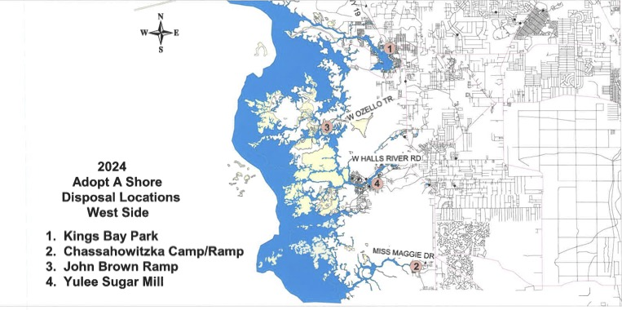
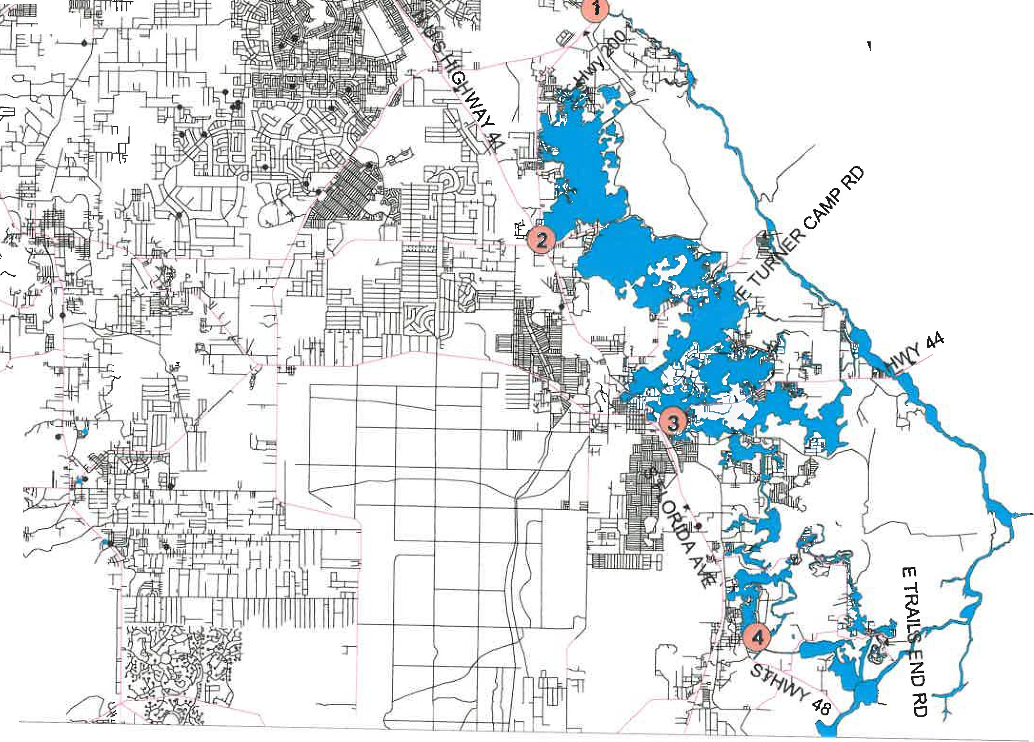

East Side Location
- C39 Ramp/Spruce St
- Hernando Ramp
- Hwy 44 Ramp
- Duval Island Ramp

